Procedural Documentation Rubric

Learner will create a final documentation portfolio that meets the following criteria
Criteria | Result (Achieve/ Not Achieve)
Lab has a title that describes its function, and the title should be a MS Word Heading
Lab has a purpose statement that briefly explains the technologies in the lab
Lab has a logical drawing showing the topology and interfaces used in the lab. For early labs, the student copies the logical drawing from the lab sheet into the document. This often given by the instructor in this class
Lab contains either a table or embeds the information in the logical drawing that shows all the IP addresses assigned and to which devices and interfaces the addresses are assigned
Lab contains a step-by-step list of the commands or actions performed that are new for the semester in the current lab and on what devices they are performed. This section will use numbered bullets in MS Word. These steps should describe the tasks to complete, and the lab and should be clear enough to be used by any student who possesses the skills obtained in the Perimeter Security class.

In the step-by-step procedures, procedures are explained the first time they are used, answering the questions what the procedure is, where it is used, why it is used, and how it is used **See Appendix A Below
Lab contains a Troubleshooting/Verification section that lists all commands/procedures, devices that the commands/procedures are on, and expected results, needed to prove the configuration works

Appendix A
When writing procedures, we want to capture the essence of how to do the new tasks while providing enough information to configure the things we already know how to do and have documented. For example, let’s say that you are learning how to assign an interface on a firewall to a security zone. Let’s also assume that the lab tells you to set assign an IP address to the interface and you have already documented how to do that in a prior lab. In most cases, a logical drawing showing your device names and an IP address table are sufficient information to be able to set up the IP addresses and test with a ping on your PCs. You wouldn’t write step-by step procedures for this part. Instead, you want to make sure that there is enough information so that someone can place the correct address on the correct interface (answer the question, what needs to be done), and create a procedure that shows exactly how to create a security zone and add an interface to it. Your first step might say:
- Configure IP addresses on the devices as shown in the table and drawing above

What you need to document now is your new procedures (all of them). In our hypothetical lab, since creating a security zone and assigning an interface to the zone is one of our new procedures, we need to answer questions what the procedure is, where it is used, why it is used, and how it is used in our steps the first time we use the command. For example:
- To create a security zone to control traffic and for aiding in creating security policies to control the flow of traffic:
- Add your outside zone: NetworkZonesAdd (Note that how to use the GUI was documented earlier, and one can assume that a student knows how to get to this menu. If it’s the first time all semester that you have used the GUI, how to access this should be documented as well)
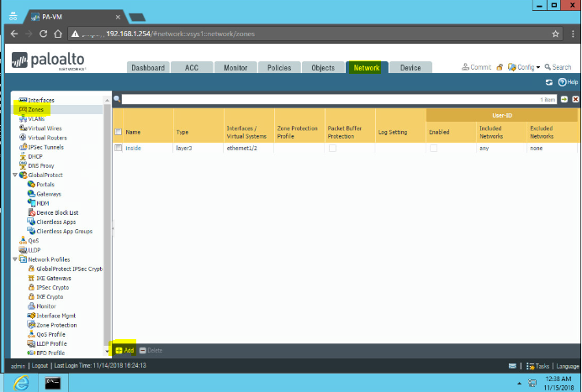
- Give it the name outside and choose Layer 3 as the type. Click OK when done.
- To assign Ethernet1/1 to the outside zone and add it to the virtual router, choose: NetworkInterfacesEthernetEthernet1/1
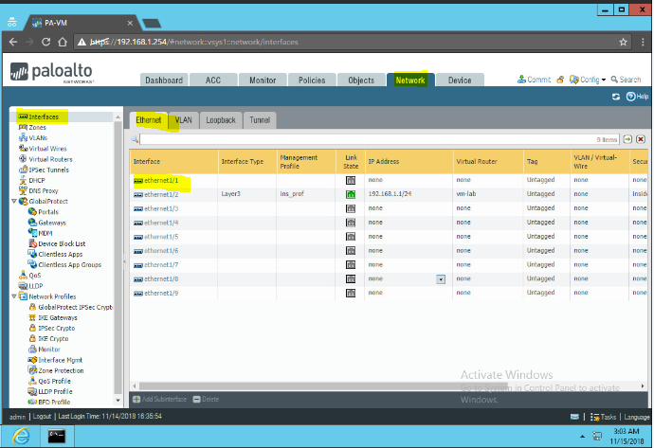
- Configure it with the following settings:
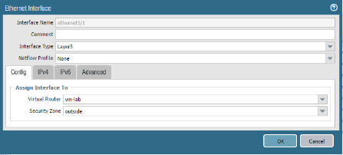

Notice the following answers are present:
- “What procedure”: (Create Security Zone and add interface)
- “Where it’s used”: (The GUI. Note that key screenshots of forms with highlights make it easier for the user who uses your documentation)
- “Why it’s used”: (To help with security policies)
- “How it’s used”: (The specific GUI menus and forms with their settings)
- You do this for all new procedures the first time they are used. If you need to use the procedure again in the current lab or in future labs, you only need to answer the question what needs to be done:
- Create a Security Zone Called Danger and assign Ethernet½ to this zone
Or
- Configure Zones and Interfaces as shown in the table above.

